LIT ASSIGNMENT DAY 10

SUBMITTED BY: MIRFA C K

EMP ID: 46255415

**Assignment 3 – Business Add in (BADI)-Single Use.'**

* Define a BADI (ZBADI_DEMO_01…05) in SE18.

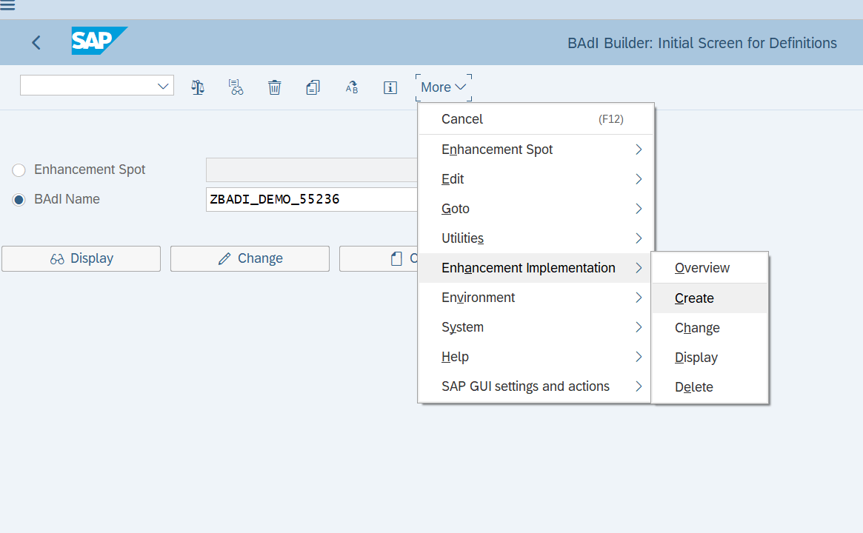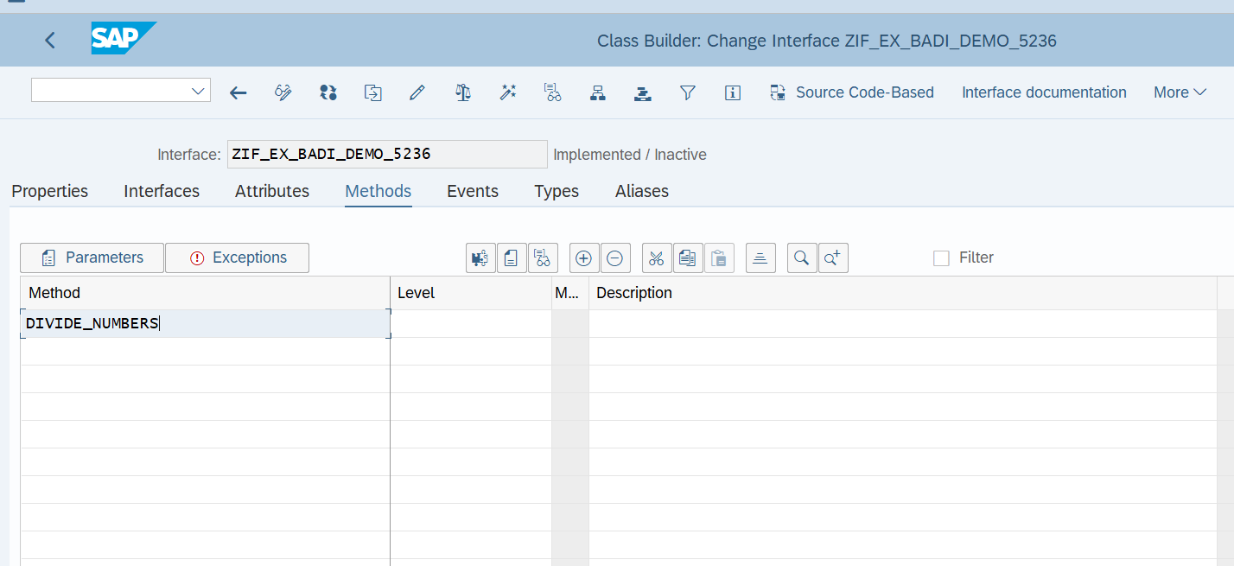  
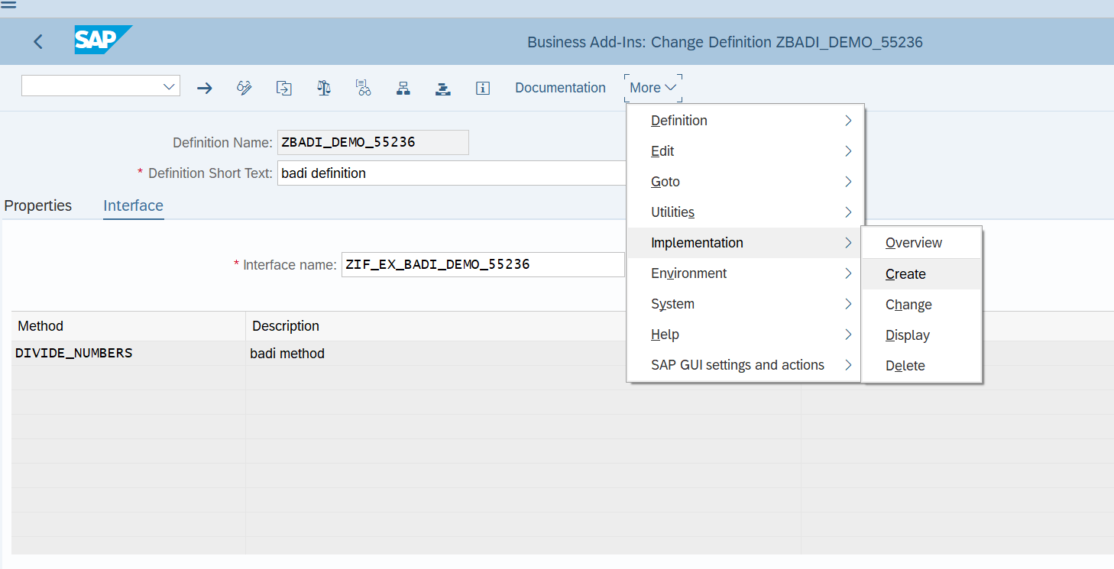  
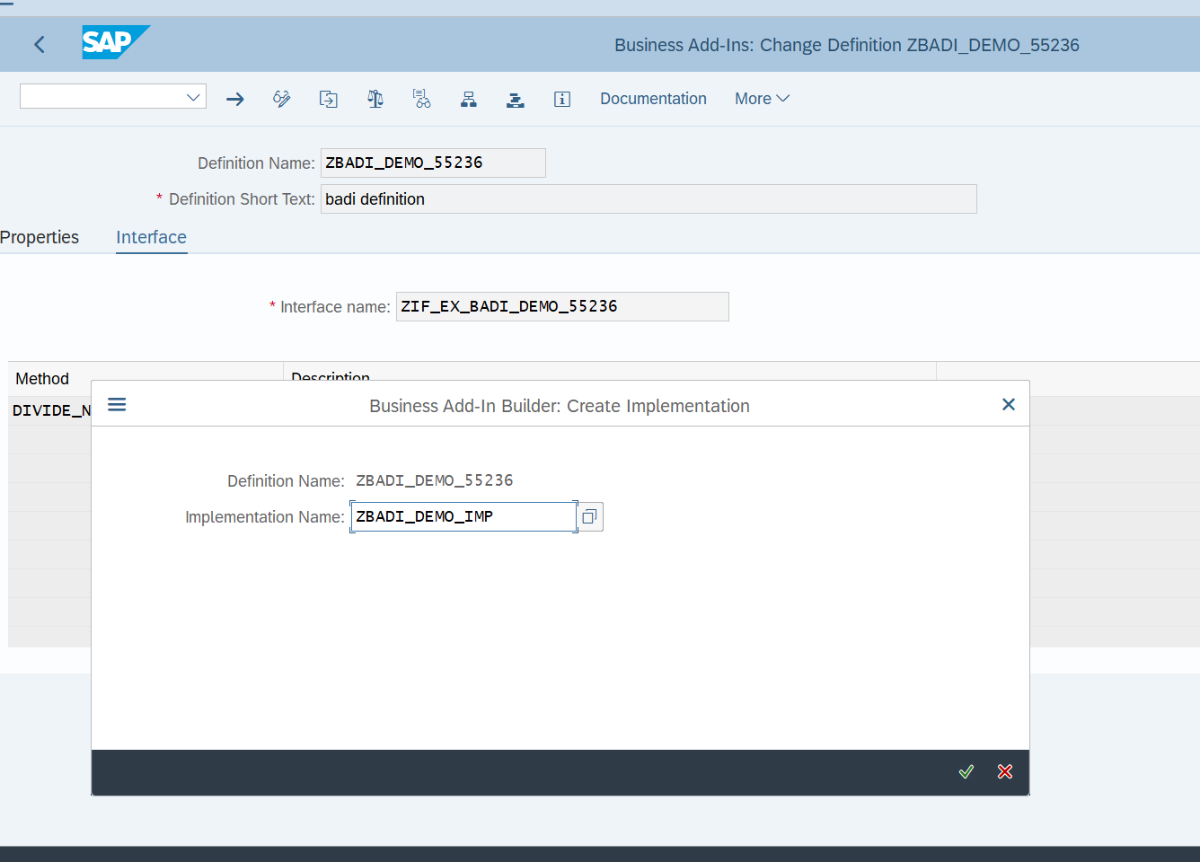  
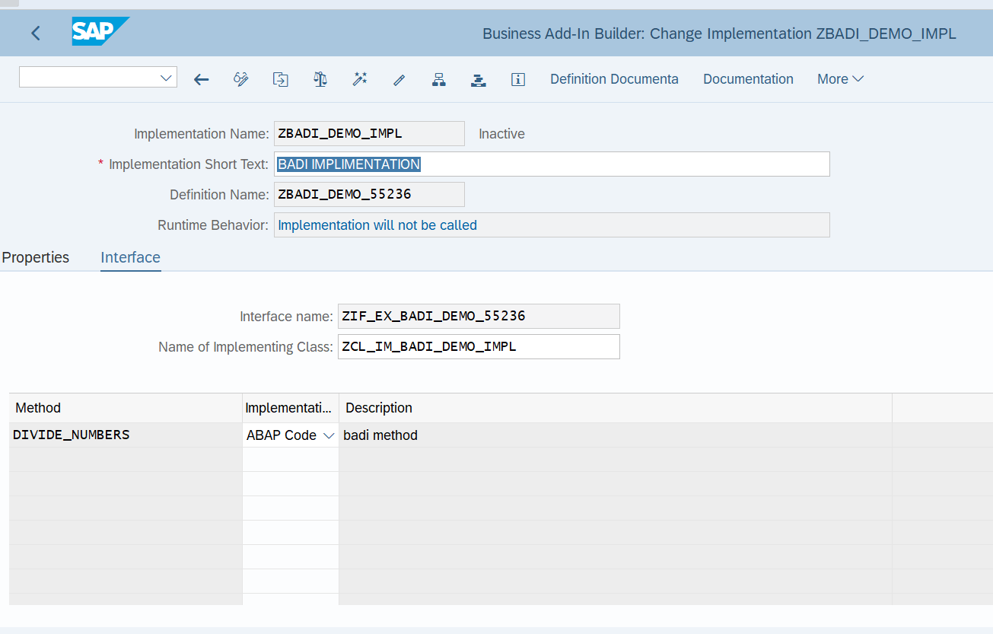  
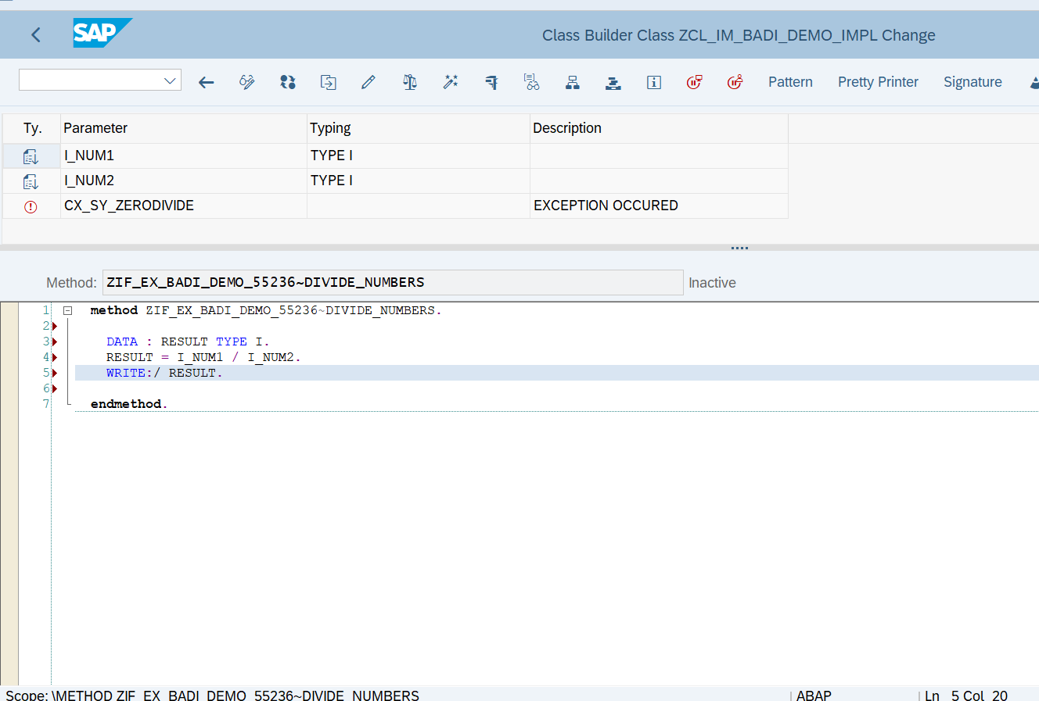  
REPORT Z415_BADI_DEMO.   
   
START-OF-SELECTION. CLASS CL_EXITHANDLER DEFINITION LOAD.   
DATA: RESULT TYPE I.   
DATA OBJ1 TYPE REF TO ZIF_EX_BADI_DEMO_55236.   
   
PARAMETERS: NUM1 TYPE I,   
            NUM2 TYPE I.   
   
CALL METHOD cl_exithandler=>get_instance   
  EXPORTING   
    exit_name                     =  'ZBADI_DEMO_55236'   
*\*    null_instance_accepted        = SEEX_FALSE*   
*\*  IMPORTING*   
*\*    act_imp_existing              =*   
  CHANGING   
    instance                      = OBJ1   
  EXCEPTIONS   
    no_reference                  = 1   
    no_interface_reference        = 2   
    no_exit_interface             = 3   
    class_not_implement_interface = 4   
    single_exit_multiply_active   = 5   
    cast_error                    = 6   
    exit_not_existing             = 7   
    data_incons_in_exit_managem   = 8   
    others                        = 9   
        .   
IF sy-subrc <> 0.   
*\* Implement suitable error handling here*   
ENDIF.   
   
TRY.   
  CALL METHOD obj1->divide_numbers   
      EXPORTING i_num1 = NUM1   
                i_num2 = NUM2 .   
 CATCH cx_sy_zerodivide .   
      
   ENDTRY.

OUTPUT:

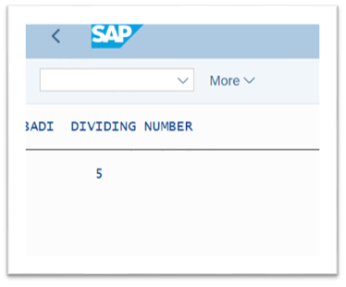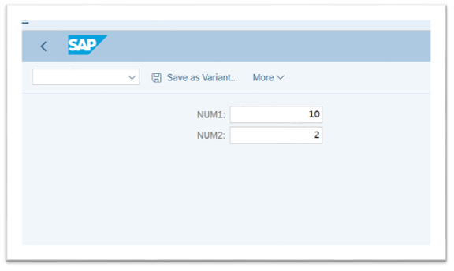



**Assignment 4 – Business Add in (BADI)-Multiple Use**

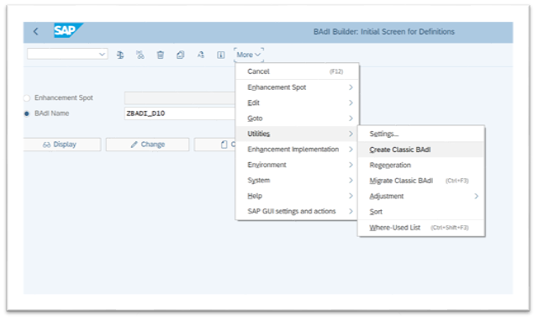

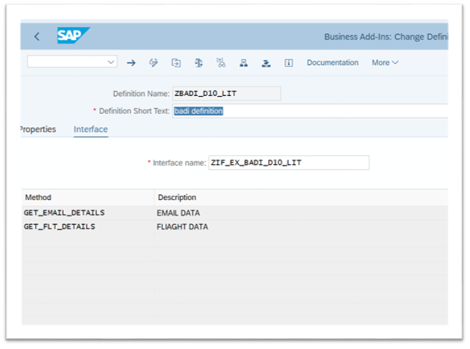

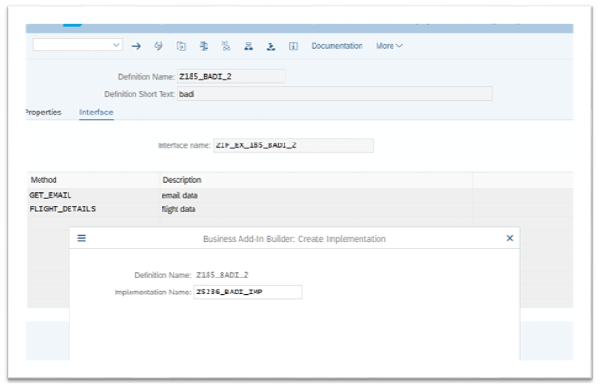

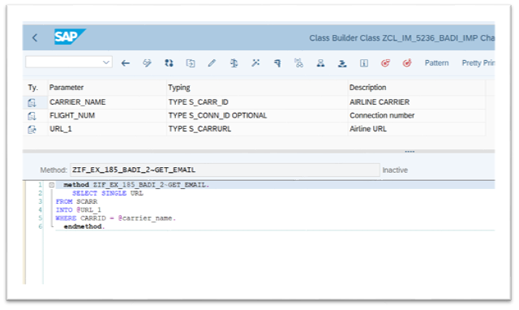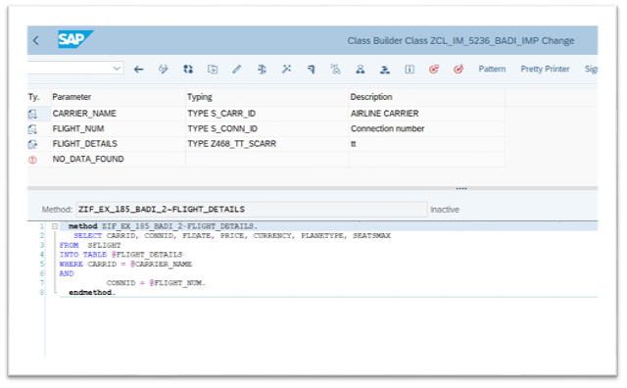

REPORT Z415D10.   
   
DATA: OBJ TYPE REF TO ZIF_EX_BADI_D10_LIT.   
   
PARAMETERS: p_carr TYPE S_CARR_ID,   
            P_flight TYPE S_CONN_ID.   
   
   
DATA : it_flight TYPE  Z468_TT_SCARR,                          *" declaring internal table of sflight*   
       gs_sflight TYPE line of Z468_TT_SCARR,   
       url type s_carrurl.   
CL_EXITHANDLER=>GET_INSTANCE(   
EXPORTING   
    EXIT_NAME                     =  'ZBADI_D10_LIT'   *" Business Add-In Definition*   
*\*    NULL_INSTANCE_ACCEPTED        =     " Is Null Instance OK if There Is no Active Implementation?*   
*\*  IMPORTING*   
*\*    ACT_IMP_EXISTING              =     " Returns an Active Implementation*   
CHANGING   
    INSTANCE                      =  OBJ   *" Instance*   
EXCEPTIONS   
    NO_REFERENCE                  = 1   
    NO_INTERFACE_REFERENCE        = 2   
    NO_EXIT_INTERFACE             = 3   
    CLASS_NOT_IMPLEMENT_INTERFACE = 4   
    SINGLE_EXIT_MULTIPLY_ACTIVE   = 5   
    CAST_ERROR                    = 6   
    EXIT_NOT_EXISTING             = 7   
    DATA_INCONS_IN_EXIT_MANAGEM   = 8   
OTHERS                        = 9   
).   
IF SY-SUBRC <> 0.   
*\* MESSAGE ID SY-MSGID TYPE SY-MSGTY NUMBER SY-MSGNO*   
*\*            WITH SY-MSGV1 SY-MSGV2 SY-MSGV3 SY-MSGV4.*   
ENDIF.   
   
CALL METHOD obj->get_flt_details   
  EXPORTING   
    carrier_name   = p_carr   
    flight_num     = p_flight   
  CHANGING   
    flight_details = it_flight   
*\*  EXCEPTIONS*   
*\*    no_data_found  = 1*   
*\*    others         = 2*   
        .   
IF sy-subrc <> 0.   
*\* Implement suitable error handling here*   
ENDIF.   
   
   
   
   
   
CALL METHOD obj->get_email_details   
  EXPORTING   
    carrier_name = p_carr   
    flight_num   = p_flight   
  CHANGING   
    url          = url   
    .   
   
   
   
WRITE: / 'Airline URL is' COLOR COL_POSITIVE,  url.   
WRITE: 40 'Flight Details' COLOR COL_POSITIVE.   
WRITE: / 'CARRID',   
10 'CONNID',   
20 'FLDATE',   
31 '      PRICE',   
52 'CURRENCY',   
63 'PLANETYPE',   
75 'SEATSMAX'.   
ULINE.   
LOOP AT it_flight INTO gs_sflight.   
WRITE : /  gs_sflight-carrid LEFT-JUSTIFIED,   
10 gs_sflight-connid,   
20 gs_sflight-fldate,   
31 gs_sflight-price,   
52 gs_sflight-currency,   
63 gs_sflight-planetype,   
75 gs_sflight-seatsmax.   
ENDLOOP.

